**Chapter 3: Quadratic Functions**

** Recall the vertex form of a quadratic function:  **

1. Match each characteristic with the correct function.

***Quadratic Function***

**A** 

**B** 

**C** 

**D** 

***Characteristic***

**I)** vertex in quadrant III ________

**II)** opens downward ________

**III)** axis of symmetry: x = 3 ________

**IV)** range:  ___________

1. Classify each as a quadratic function or a function that is not quadratic.

**a)**  _________________________

**b)**  _________________________

**c)** _________________________

**d)**  _________________________

1. Sketch the graph of the following quadratic functions:

**a) **

**b)** opens upward, vertex at (1, -3), one x-intercept at the point (3,0). Write its equation.

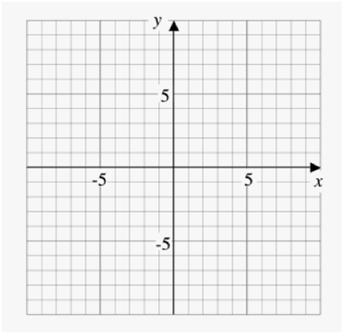

1. Identify the vertex, domain, range, axis of symmetry, x-intercepts and y-intercept for each quadratic function.

**a)**  **b)** 

1. Rewrite each function in the form . Compare the graph of each function to the graph of .

**a)**  **b)** 

1. **a)** The approximate height, *h*, in meters, of an arrow shot into the air with an initial velocity of 20 m/s after *t* seconds can be modeled by the function . What is the maximum height reached by the arrow?

**b)** From what height was the arrow shot?

**c)** How long did it take for the arrow to hit the ground, to the nearest second?

**Chapter 4: Quadratic Equations**

1. Solve by the indicated method.

**FACTORING**

**a)**  **b)** 

**COMPLETING THE SQUARE**

**c)** 2(*x* – 3)2 – 8 = 0 **d)**

**QUADRATIC FORMULA (leave exact answers please!)**

**e)** 3*x*2 + 19*x* – 14 = 0  **f)** 2*x*2 – 4*x* –3 = 0

1. The sum of the squares of three consecutive integers is 194. What are the integers?
2. Use the discriminant to determine the nature of the roots for each quadratic equation.

**a)**  **b)**  **c)** 

1. A pig pen is being designed against the side of a barn. There is a total of 70 m of fencing available.

**a)** Write a quadratic function to model the area of the pigpen.

**b)** What is the maximum area possible?

**c)** If the area is known to be exactly 320 what are the dimensions of the pen?