**Chapter 7: Absolute Value and Reciprocal Functions**

1. Order the values from least to greatest.



1. Write the piecewise function that represents each graph.

**a)** **b)**

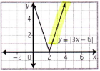 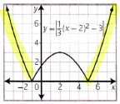

1. For each absolute value function,

**i)** sketch the graph, **ii)** determine the intercepts **iii)** determine the domain and range.

**a)**  **b)** 

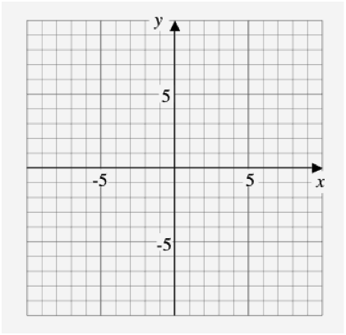 

1. Solve algebraically. Verify your solutions.

**a)**   **b)** 

1. Sketch the graph of  given the graph of  . What is the original function, ?

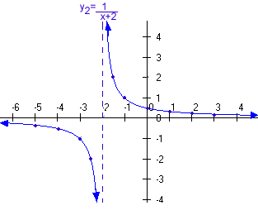

1. Sketch the graph of  given  . Label the asymptotes, the invariant points, and the intercepts.



**Chapter 2: Trigonometry**

1. Determine the exact distance, in simplified form, from the origin to a point P (-2, 4) on the terminal arm of an angle.

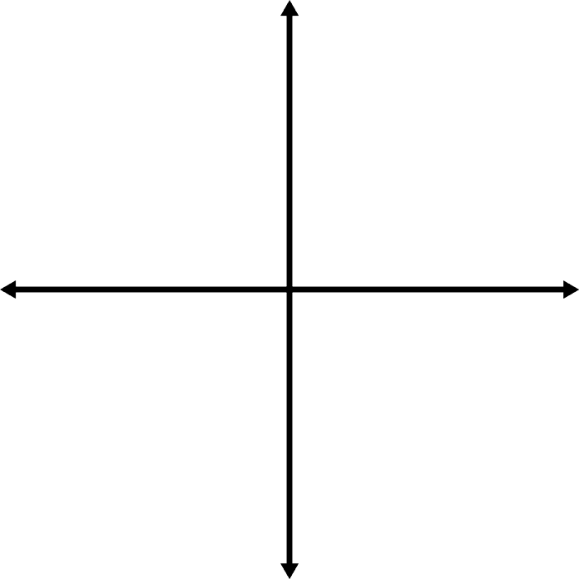

1. Point P (15,8) is on the terminal arm of angle . Determine the exact values for ,  and .



1. Sketch each angle in standard position and determine the measure of the reference angle.

**a)**  **b)**  **c)**  **d)** 

   

1. Determine the **exact** value of each trigonometric ratio.

**a)**  **b)** 

**c)**  **d)** 

1. Radio collars are used to track polar bears by sending signals via GPS to receiving stations. Two receiving stations are 9 km apart along a straight road. At station A, the signal from one of the collars comes from a direction of  from the road. At station B, the signal from the same collar comes from a direction of  from the road. Determine the distance the polar bear is from each of the stations.
2. In , RT = 2 m, ST = 1.4 m, and . Determine the measure of obtuse  to the nearest tenth of a degree.